1.70:
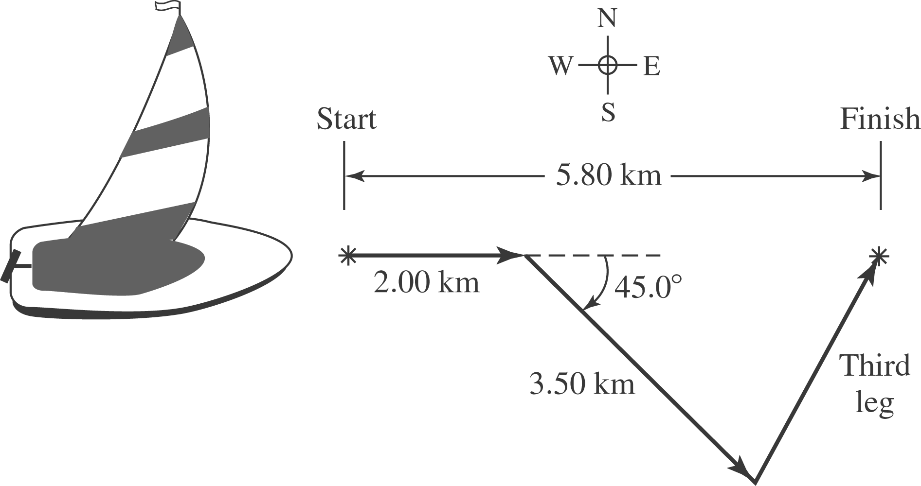

The third leg must have taken the sailor east a distance

and a distance north

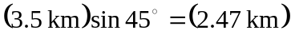
The magnitude of the displacement is

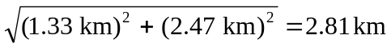

and the direction is arctan 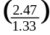= 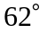 north of east, which is east of north. A more precise answer will require retaining extra significant figures in the intermediate calculations.

